Module 4 – Question 4
Question Name: Count the Digits That Divide a Number
Platform: LeetCode
Programming Language: C
Problem URL: https://leetcode.com/problems/count-the-digits-that-divide-a-number/
Problem Statement
Given an integer num, return the number of digits in num that divide num.
An integer val divides num if num % val == 0.
Input Format
A single integer num.
Output Format
Return the number of digits in num that divide num.
Constraints
- 1 <= num <= 10^9
- num does not contain 0 as one of its digits.
Sample Input 1
7
Sample Output 1
1
Explanation
7 divides itself, hence the answer is 1.
Sample Input 2
121
Sample Output 2
2
Explanation
121 is divisible by 1, but not 2. Since 1 occurs twice as a digit, we return 2.
Sample Input 3
1248
Sample Output 3
4
Explanation
1248 is divisible by all of its digits, hence the answer is 4.
Code Screenshot
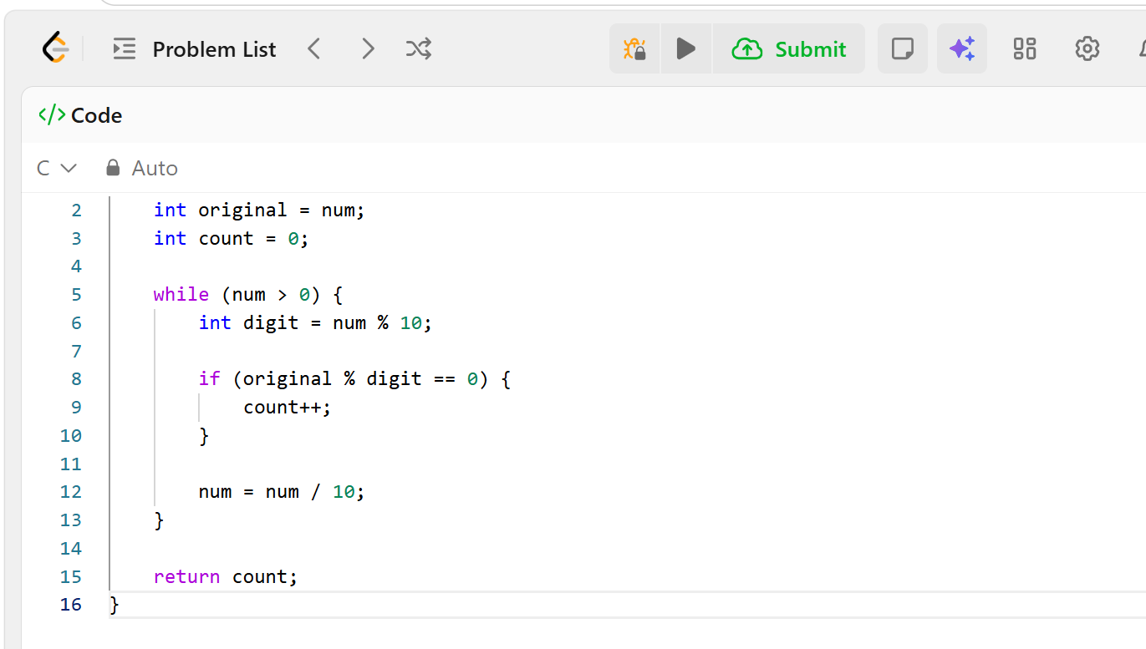Output Screenshot
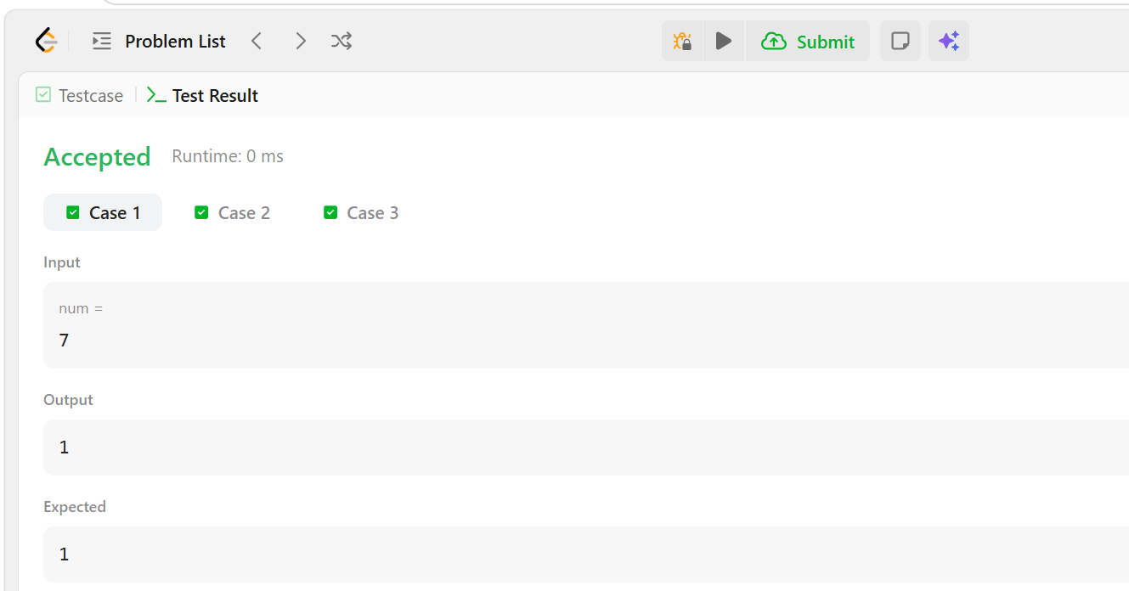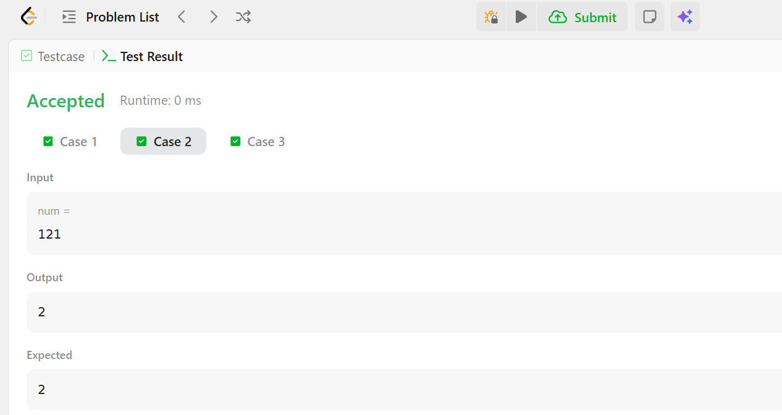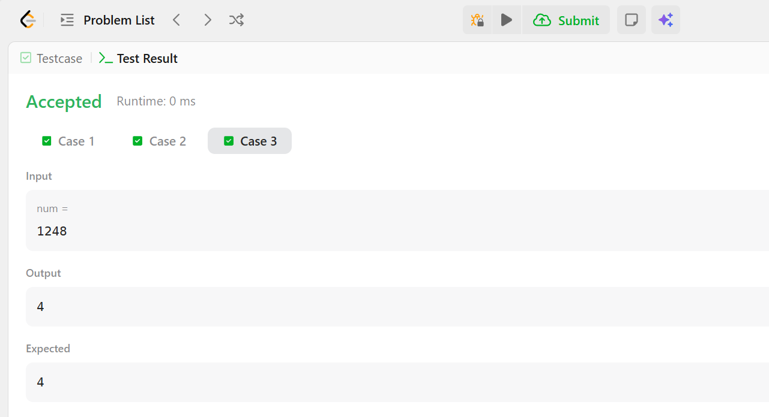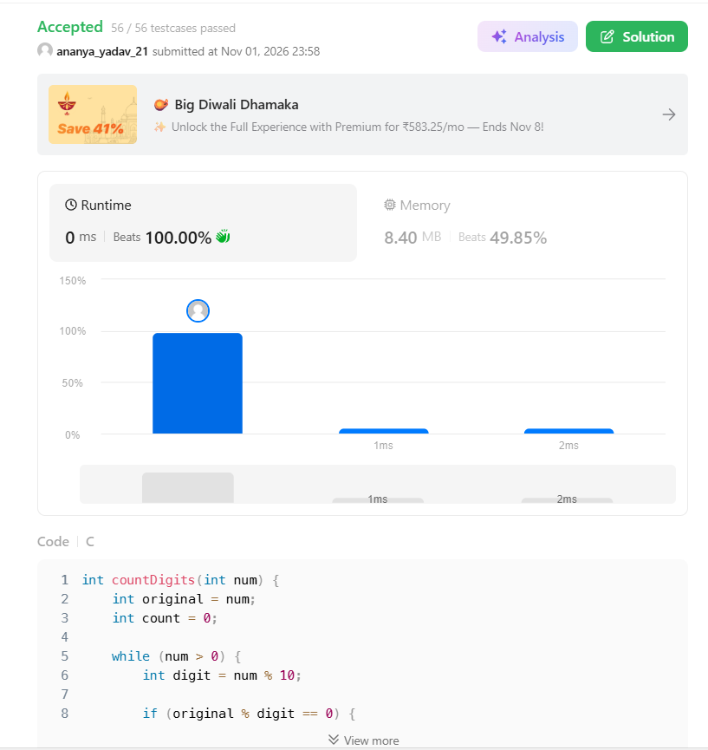Result
The program was implemented successfully. It checks each digit of the given number and counts how many digits divide the original number without leaving a remainder. The expected outputs for all three examples are 1, 2, and 4 respectively.

